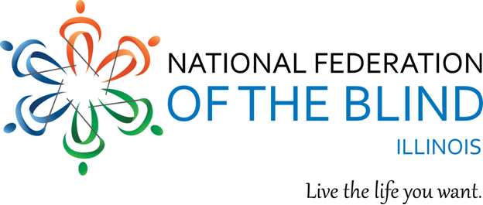
1National Federation of the Blind of Illinois Logo

2018 Mid-West Regional Seminar

What’s Next for You?

Hosted by: the Illinois Association of Blind Students
the student chapter of the National Federation of the Blind of Illinois

Who: blind and low vision students (high school and up)
When: 6PM, Friday, April 20 – 12PM, Sunday, April 22, 2018
Where: Holiday Inn O’Hare, 5615 N. Cumberland Avenue, Chicago, IL 60631
Cost: $50 for meals and registration, Sleeping room $109 plus tax per night
To reserve a room, call 773-693-5800. Mention NFB of Illinois to get our special group rate!
Want roommates to cut down costs? Email Kathryn Webster at nabs.president@gmail.com
WHY WAIT? Event and hotel registration is open from February 1 – March 31, 2018
Visit: www.nabslink.org to register!
Direct questions and special requests to Kathryn Webster at: nabs.president@gmail.com
If you are an Illinois student seeking financial assistance, go to www.nfbofillinois.org, and fill out the Chappell Dennis form. Forms must be sent back to NFBI President, Denise R. Avant at davant1958@gmail.com by March 20, 2018.

This year’s regional student seminar will be a weekend of fun, engagement, and information!
It’s all about the next step in your life, whatever that may look like: taking a step back, learning about options, and paving the path for your future. We will have experts from blindness training centers, working professionals, career guidance, college preparation, health & wellness, and so much more. This seminar gives students an invaluable tool: the power of networking. Both Friday and Saturday night, we will engage in activities and social events. With students traveling from neighboring states, the interactions you’ll experience will be unlike anything else!

In the National Federation of the Blind, Blind Americans work together to break down barriers so that we can live the lives we want.

